Chang’an University 2025－2026 The 2nd semester （ A ）
Course | Hydraulic and Pneumatic Transmission |  |  | Date |  | / / |  | 18 questions
Name |  | School |  |  | Class |  | ID
I Fill in the blanks. (20 points, 1 point for each blank)
- The working pressure in a hydraulic system depends on the external load; the speed of the actuator depends on the flow rate.
- Liquids that are assumed inviscid and incompressible are called ideal fluids.
- The viscosity of liquid decreases with increasing temperature; the viscosity of gas increases with increasing temperature.
- There are two flow regimes in pipelines: laminar flow (dominated by viscous force) and turbulent flow (dominated by inertial force).
- Pressure loss includes major loss along pipes and minor loss at local fittings.
- A double-acting vane pump delivers oil twice per revolution; a single-acting vane pump delivers oil once per revolution.
- Hydraulic motors convert ( hydraulic ) energy into ( mechanical ) energy.
- The main pressure control valves are relief valve, pressure reducing valve, sequence valve, and pressure switch.
- A speed control valve consists of a throttle valve and a differential pressure reducing valve in series.
- Sequence action circuits allow several actuator motions to obey the setting scheduled actions in turn. There are two kinds of control methods: ( pressure ) control and ( position ) control.
II Single Choice (10 points, 2 points for each)
- The continuity equation is based on ___B_____.
A. energy conservation B. mass conservation C. momentum conservation D. force balance
- To reduce hydraulic shock, we can ___C_____.
A. increase flow rate B. shorten closing time C. lengthen closing time D. increase pipe length
- A variable hydraulic motor can change its ____B____.
A. pressure B. displacement C. viscosity D. density
- The ____C____ maintains a constant outlet pressure regardless of inlet pressure.
A. relief valve B. check valve C. pressure reducing valve D. sequence valve
- Which hydraulic circuit is used to maintain a constant pressure in the system ____B____.
A. Speed control circuit B. Pressure holding C. Synchronization circuit D. Direction control circuit

第 1 页(共 4 页)
III Short answer question items. (30 points, 6 points for each)
- List five components of a hydraulic drive system.

Power unit (pump), actuators, control valves, auxiliary components, working fluid.

- What are the advantages of hydraulic transmission?

High power density; stepless speed regulation; overload protection; easy layout; automatic lubrication.

- Explain the trapped-oil phenomenon in gear pumps and give one solution.
when the gear pump is in operation, two pairs of gears will form a closed oil chamber during the simultaneous meshing process. This oil chamber is not connected to the suction and pressure chambers, and the oil is trapped in this closed volume. As the gears rotate, the size of this enclosed volume will change. Pressure shock and cavitation occur.
Solution: open unloading grooves.

- State the working principle of a pressure-limiting variable vane pump.
The working principle of a pressure limiting variable vane pump is mainly based on the interaction between the rotor and stator, as well as the shape and angle changes of the blades.
This type of pump controls the output flow and pressure of the pump by changing the eccentricity between the rotor and stator. When the pump starts, the impeller rotates, and the blades rotate accordingly, forming a low-pressure zone, which automatically sucks in the liquid. The liquid rotates in the pump chamber, and the blades are pushed by the liquid to continue rotating, producing a liquid flow.
When the working pressure of the pump is lower than the limit pressure, the output flow rate of the pump is maximum; When the pressure exceeds the limit pressure, eccentricity decreases, the output flow of the pump will decrease to prevent overload.
- Compare relief valve and pressure reducing valve.
Relief valve controls inlet pressure, normally closed. Reducing valve controls outlet pressure, normally open.
IV Diagramming question. (10 points)
1. Please write the name of basic hydraulic circuits and hydraulic components.
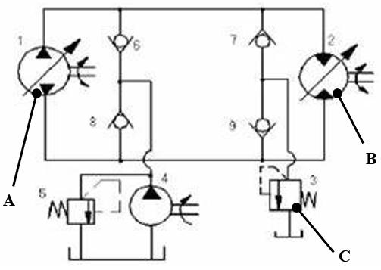 | 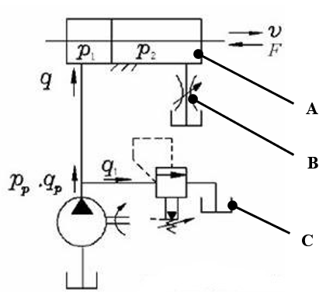
(1) (2)
Hydraulic basic circuit | Volume speed regulating circuit |  | Hydraulic basic circuit | Outlet throttle speed regulating circuit
Component A | Bidirectional variable pump |  | Component A | Double-acting double-piston rod hydraulic cylinder
Component B | Bidirectional variable motor |  | Component B | Throttle valve
Component C | Direct-acting relief valve |  | Component C | Reservoir (oil tank)

第 2 页(共 4 页)

Ⅴ Calculations. (30 points, 10 points for each)
- This is shown in the figure below, known water depth H =10m, section A₁=0.02m², and section A₂= 0.04m², try to find the outflow flow rate of the hole and the surface pressure at point 2 (α=1, regardless of loss).
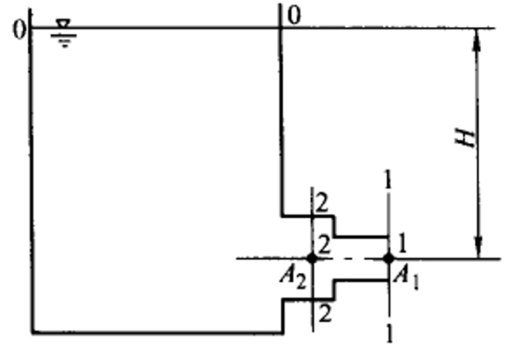
Solution: Bernoulli equations are written with 0-0 and 1-1 faces, and the kinetic energy correction coefficient α=1, then
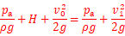
So we get this from the above equation
According to the flow continuity equation
So
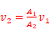
Bernoulli equations are listed for sides 1-1 and 2-2
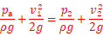
Because Pa=0(manometer pressure),so
The outflow rate of the orifice

第 3 页(共 4 页
- The inlet pressure of a hydraulic motor is 10MPa, the displacement is 200mL/r, the total efficiency is 0.75, and the mechanical efficiency is 0.9.
1) The theoretical torque that the motor can output.
2) If the speed of the motor is 500r/min, what is the flow rate input to the hydraulic motor?
3) If the external load is 200 N∙m (n= 500r/min), what is the output power and input power of the motor? (10 points)
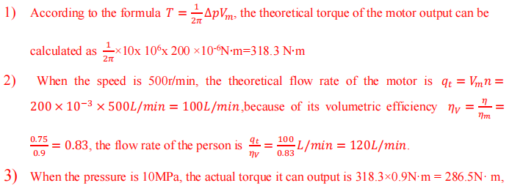

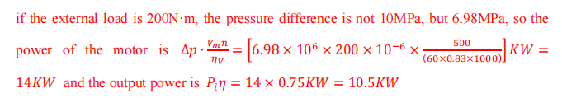
- Hydraulic circuit as shown in figure, the no rod cavity area of hydraulic cylinder A=50cm2 , load F=10000N. The set pressure of each valve is shown in the figure, this system is assumed lossless. Calculate the pressure at point A and B when the piston is moving and after the piston moves to the end.
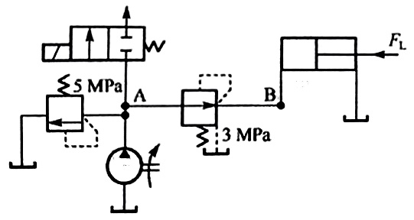
1) When the piston moves
Since the working pressure only needs 2 MPa, the set pressure of the pressure reducing valve is 3 MPa, and the pressure reducing valve does not work, so PB=2 MPa. The set pressure of the overflow valve is 5 MPa, and the overflow valve does not work, so PA=2 MPa
(2) When the piston stops at the end
When the piston stops at the end, because the load increases infinitely, the pressure in the left chamber of the hydraulic cylinder is held up, and the pressure reducing valve works to reach its set pressure: so PB=3 MPa. The pressure at point A continues to be held up, and when it reaches the set pressure of the overflow valve, the overflow valve overflows, so PA=5 MPa
第 4 页(共 4 页)

